ECEN 325

Lab 4: Operational Amplifiers - Part 2

Section 506

02/21/2020

Jason Gilman

TA: Mandela

**Introduction:**

In this lab, we were tasked with studying the fundamental properties of advanced configurations of operational amplifiers. We constructed and tested various configurations including summing, differential, and instrumentation operational amplifiers.

**Calculations:**

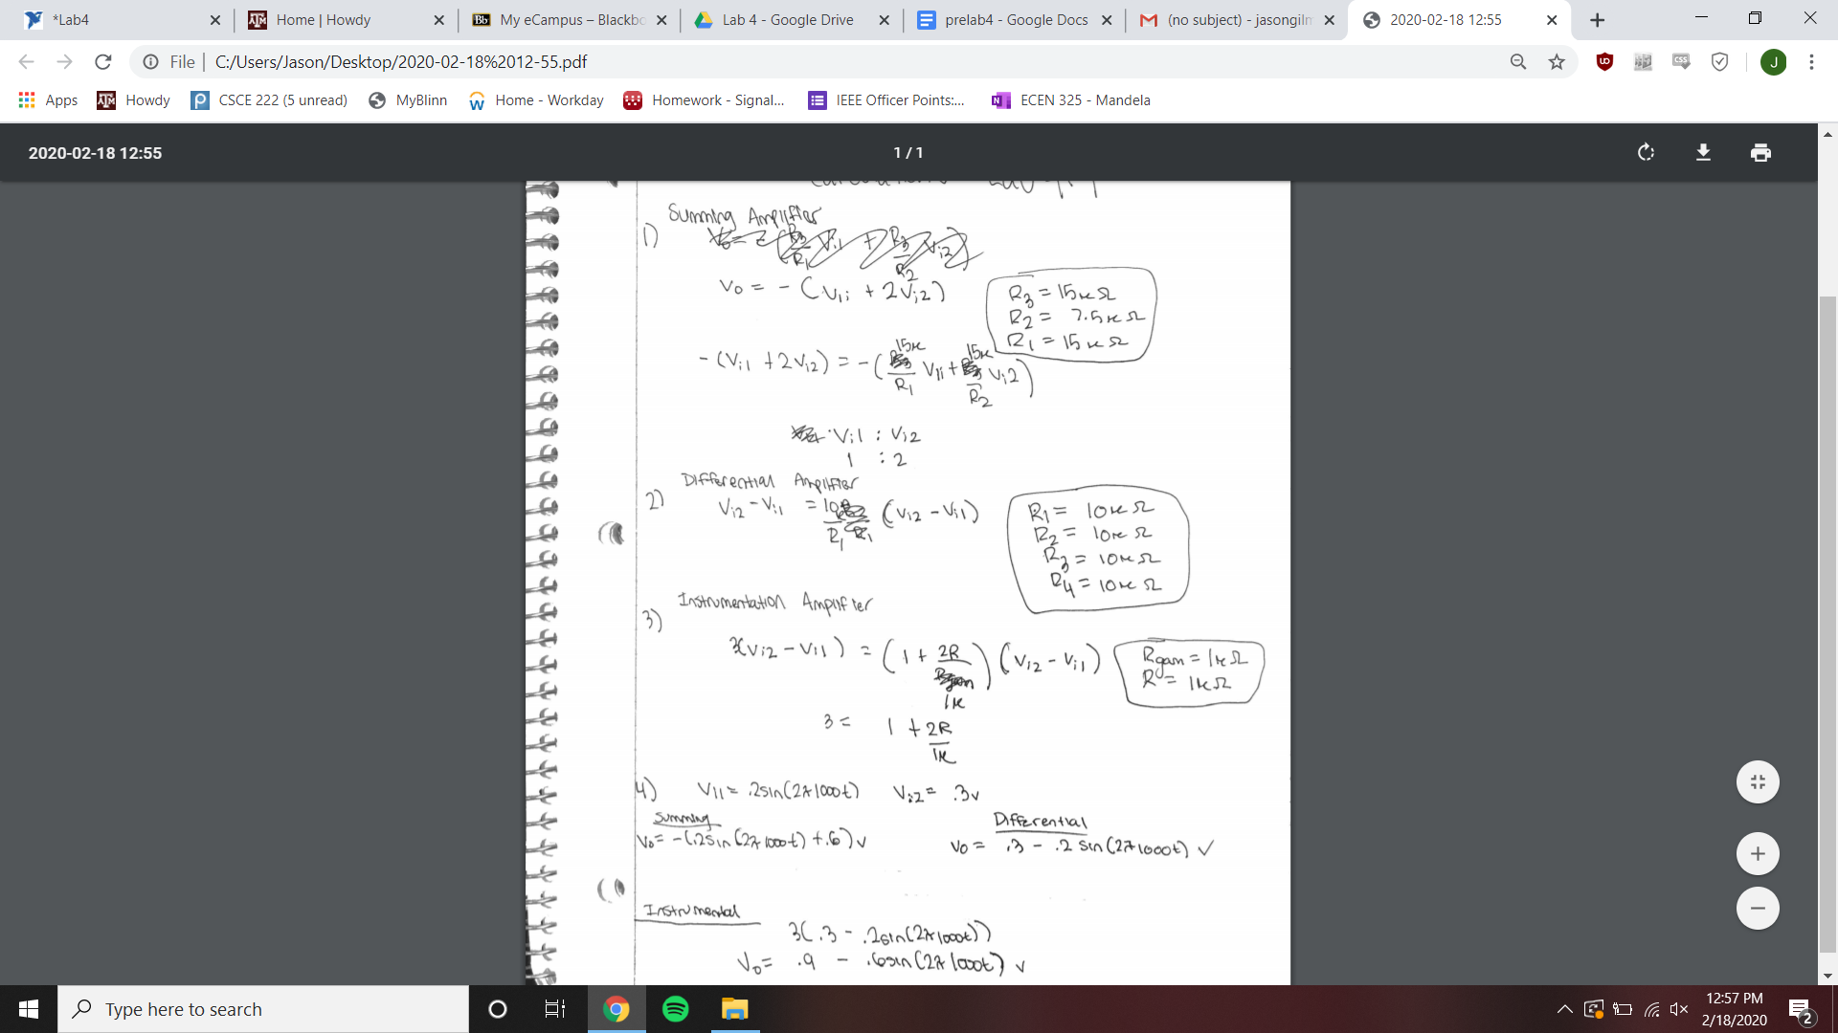

**Schematics:**

Summing Amplifier

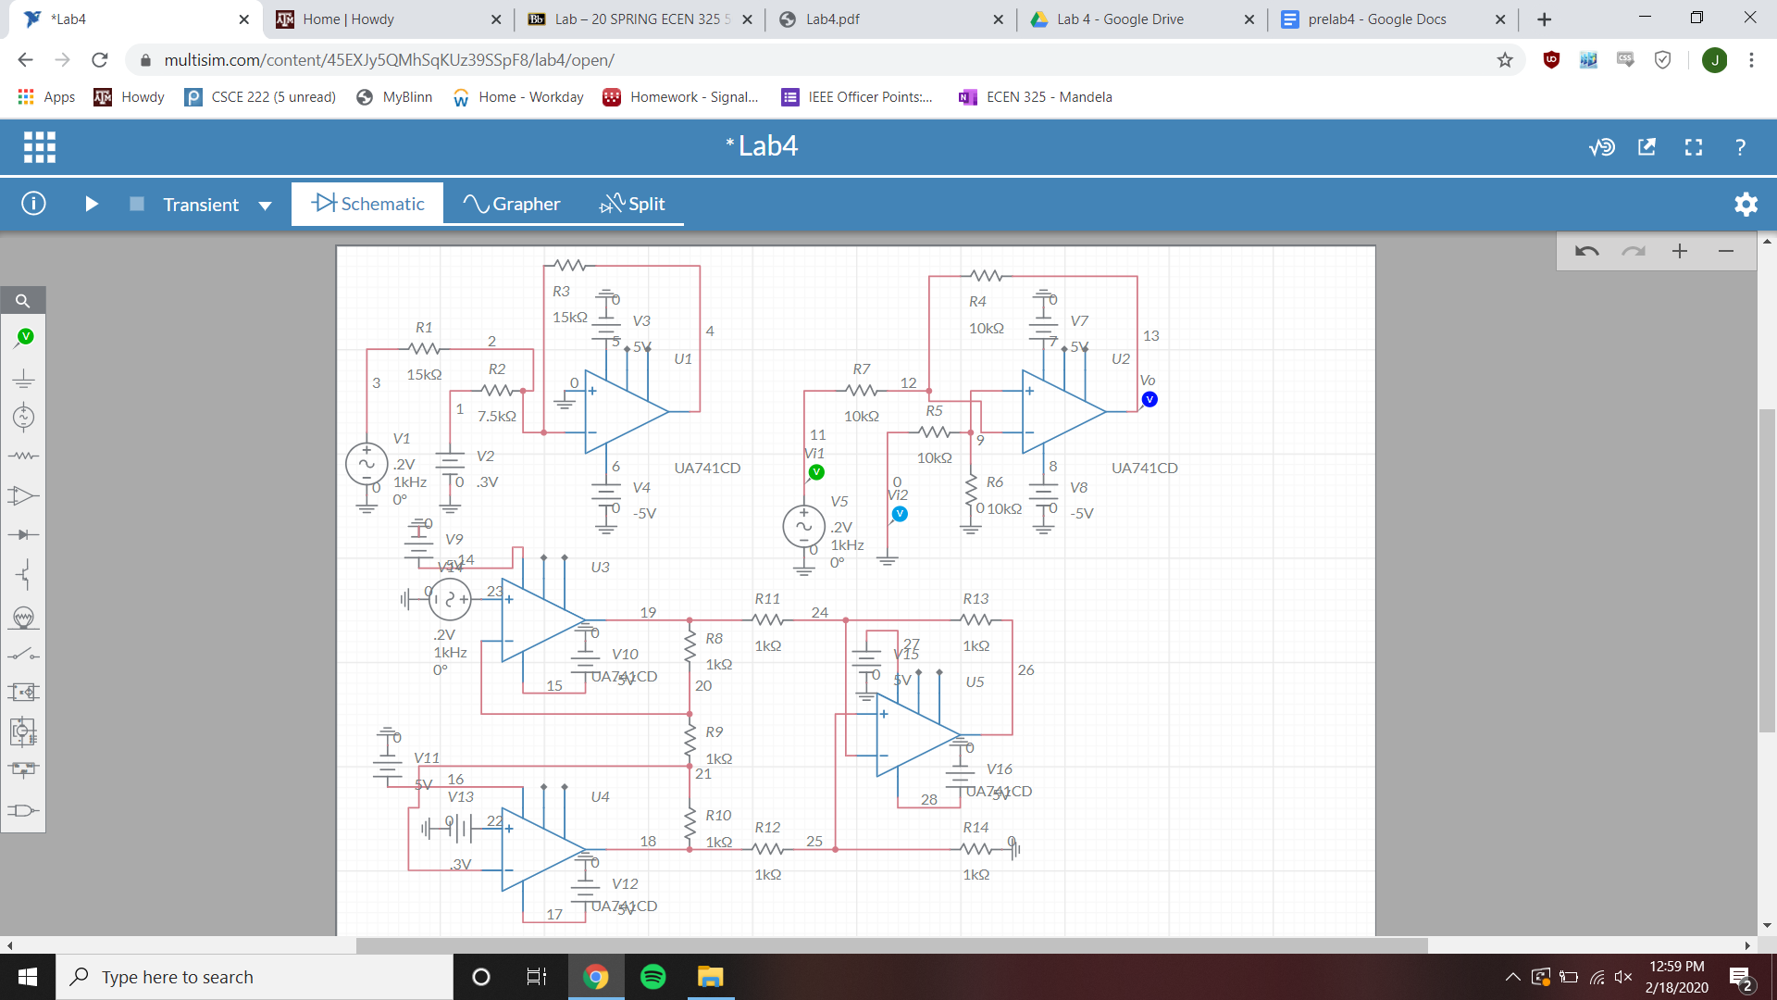

Differential Amplifier



Instrumentation Amplifier



**Simulations:**

Summing Amplifier Time-Domain Simulation

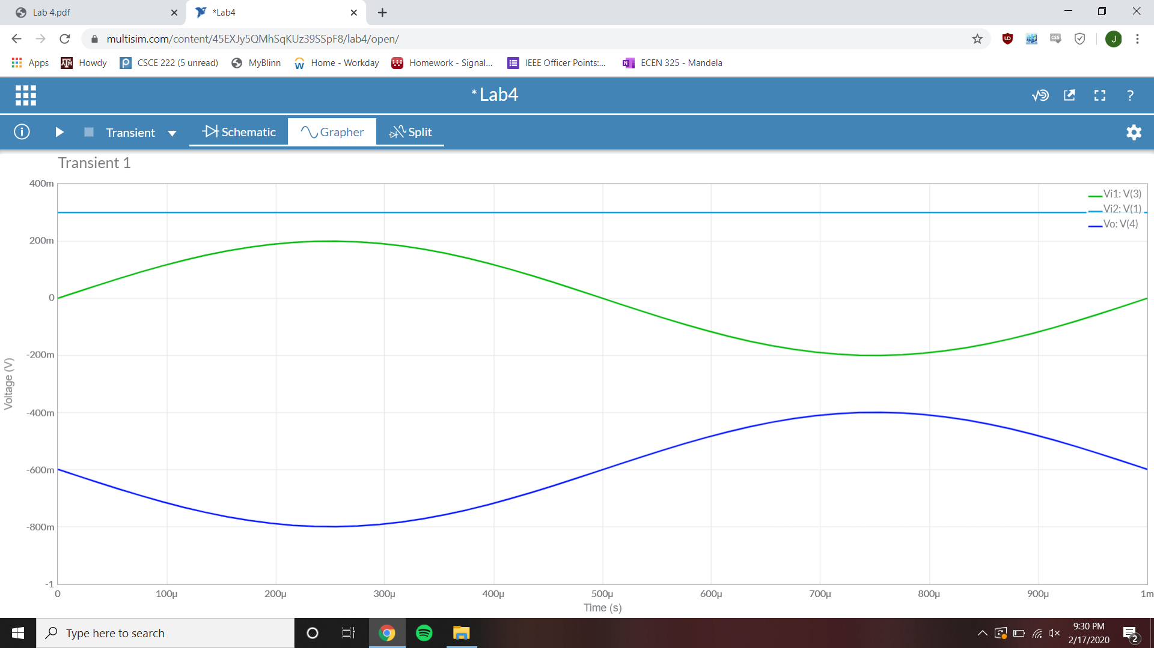

Vi1 Amplitude = .2 V Vi2 Amplitude = .3 V Vo Amplitude = .2 V

Differential Amplifier Time-Domain Simulation

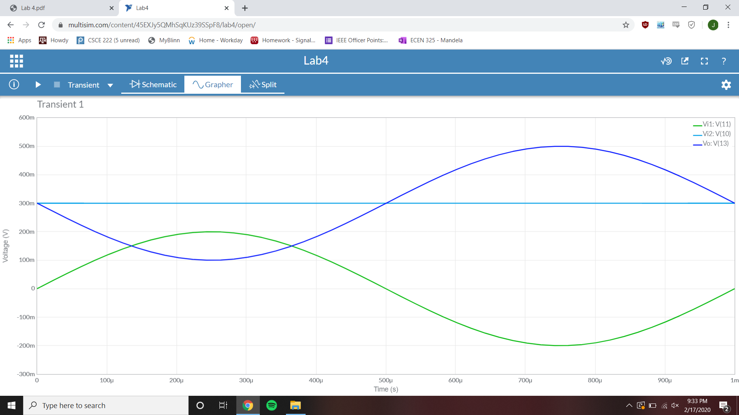

Vi1 Amplitude = .2 V Vi2 Amplitude = .3 V Vo Amplitude = .2 V

Instrumentation Amplifier Time-Domain Simulation

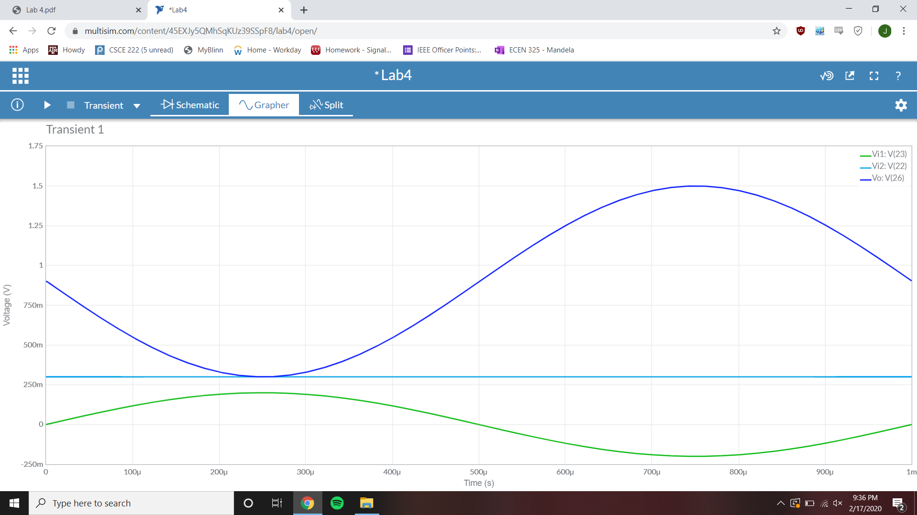

Vi1 Amplitude = .2 V Vi2 Amplitude = .3 V Vo Amplitude = .6 V

**Measurements:**

Summing Amplifier Time-Domain Measurement

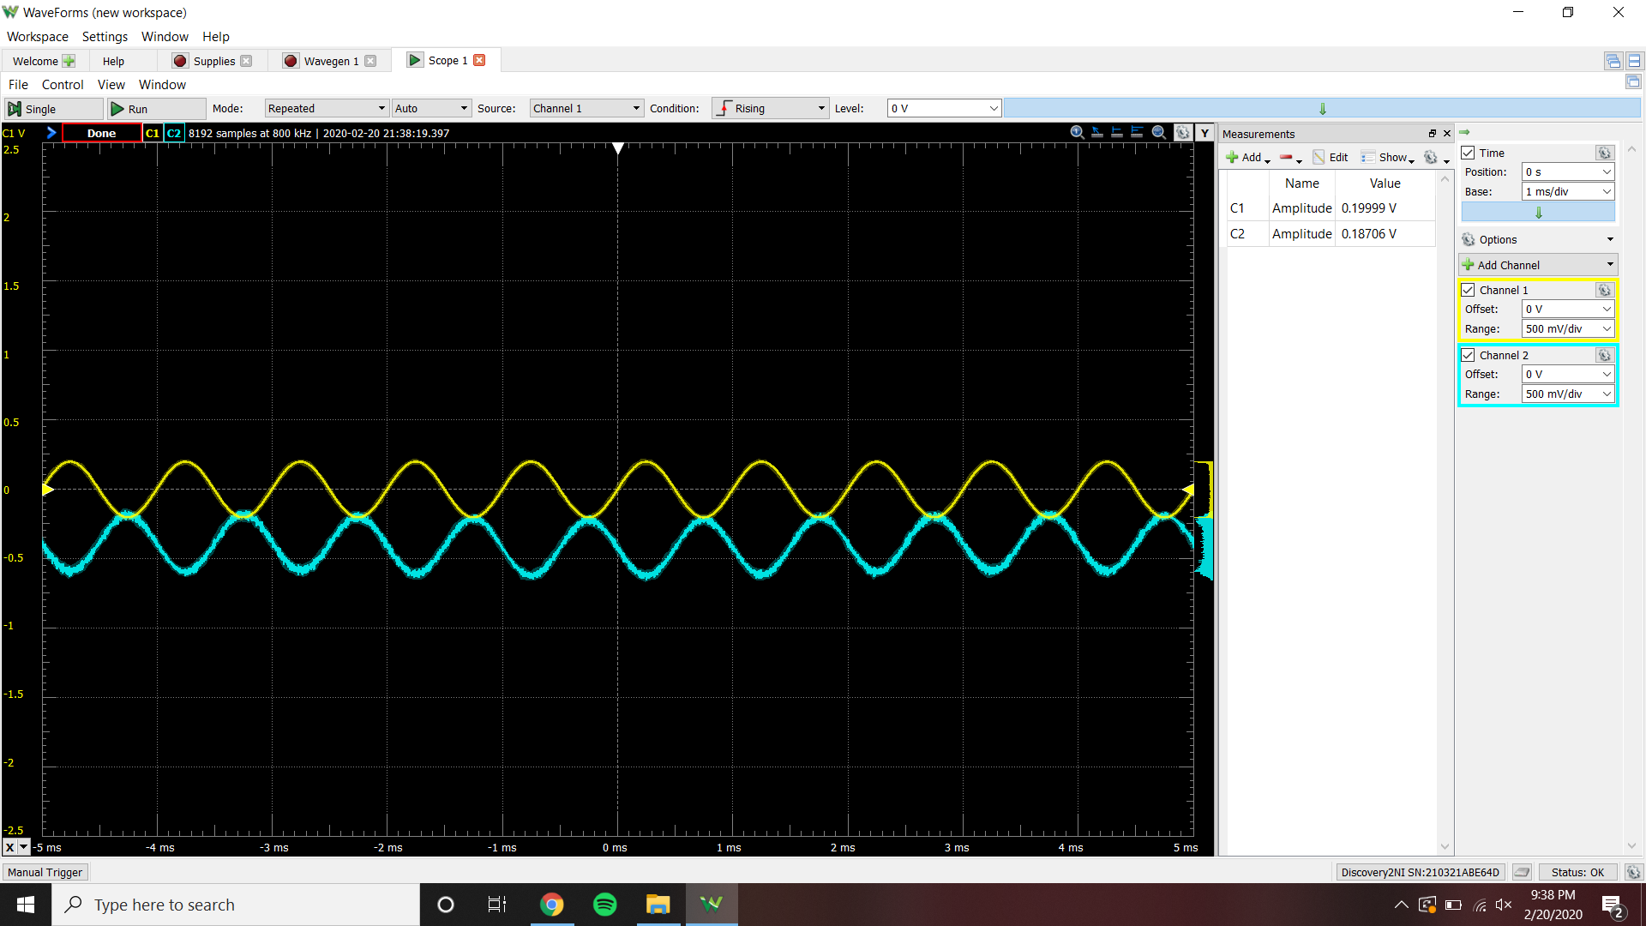

Vi1 Amplitude = .1999 V Vi2 Amplitude = .3 V Vo Amplitude = .18706 V

Summing Amplifier Clipping Measurement

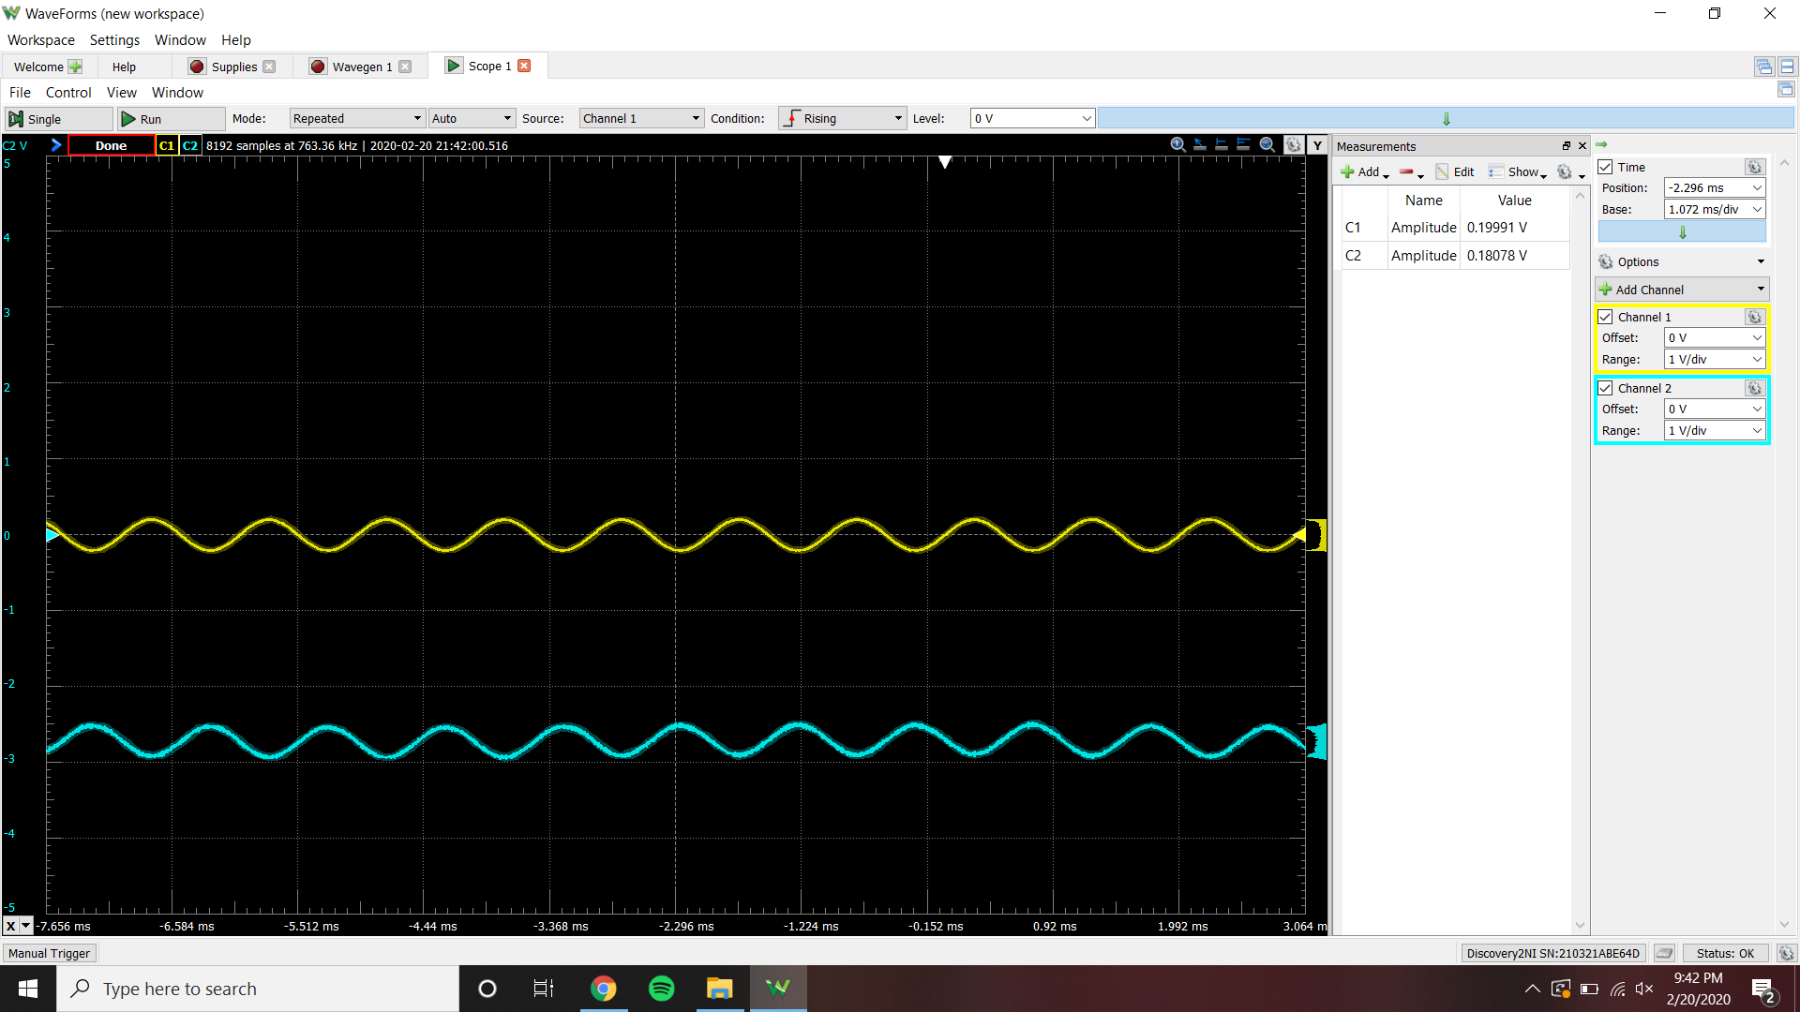

Vi2 = 1.44 V when clipping begins to occur in Vo signal

Differential Amplifier Time-Domain Measurement

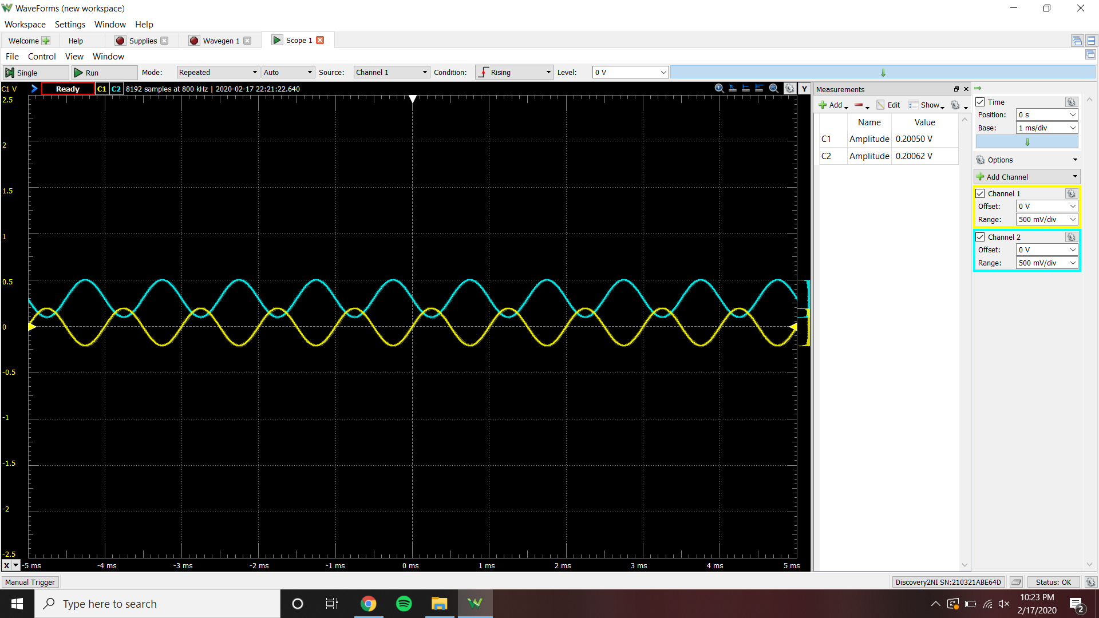

Vi1 Amplitude = .20005 V Vi2 Amplitude = .3 V Vo Amplitude = .20062 V

Adm = .20062 V / (0 V - .1999 V) = -1.00315 V/V

Acm = .000169 V / .1999 V = .000848 V/V

CMRR = Adm / Acm = 1182.96 V/V = 61 dB

Instrumentation Amplifier Time-Domain Measurement

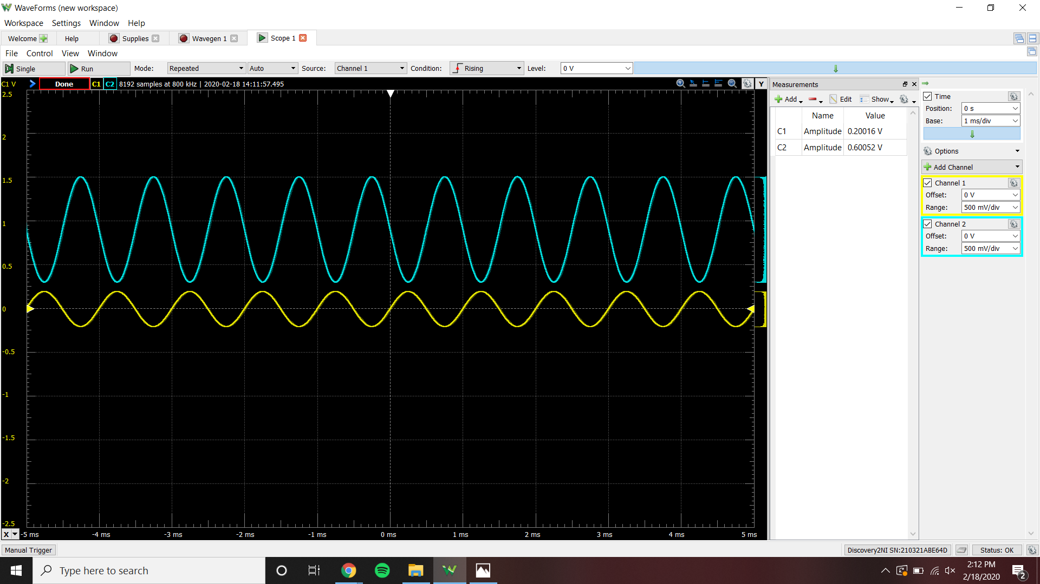

Vi1 Amplitude = .20016 V Vi2 Amplitude = .3 V Vo Amplitude = .60052 V

|  |  |  |
| --- | --- | --- |
|  | Simulated | Measured |
| Summing, Vi1 | .2 V | .1999 V |
| Summing, Vi2 | .3 V | .3 V |
| Summing, Vo | .2 V | .18706 V |
| Differential, Vi1 | .2 V | .20005 V |
| Differential, Vi2 | .3 V | .3 V |
| Differential, Vo | .2 V | .20062 V |
| Instrumentation, Vi1 | .2 V | .20016 V |
| Instrumentation, Vi2 | .3 V | .3 V |
| Instrumentation, Vo | .6 V | .60052 V |

**Conclusion:**

Looking at the table comparing simulated and measured results for Vi1, Vi2, and Vo, all of the values are acceptable and reflected by the other form of measurement. The only differences between the two values are in the scale of .001 mV which is negligible, and possibly due to the resistors and operational amplifiers not being ideal.